Incident Response Playbook and Implementation for Catnip Games SOC



Section 1: General Incident Response Playbook

Purpose & Scope

This playbook defines a standardised framework for responding to cybersecurity incidents across environments.

Objectives
- Define severity levels
- Provide structured response process
- Support communication and coordination

Incident response phases
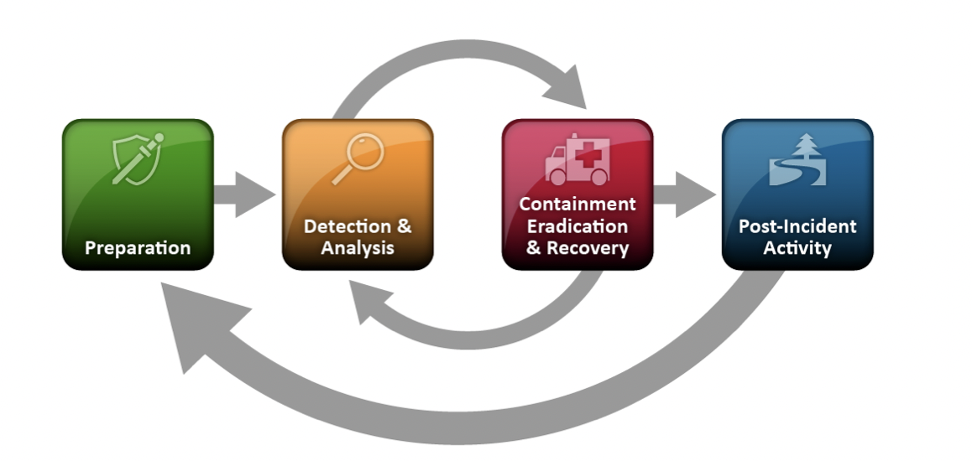

Incident Response Workflow
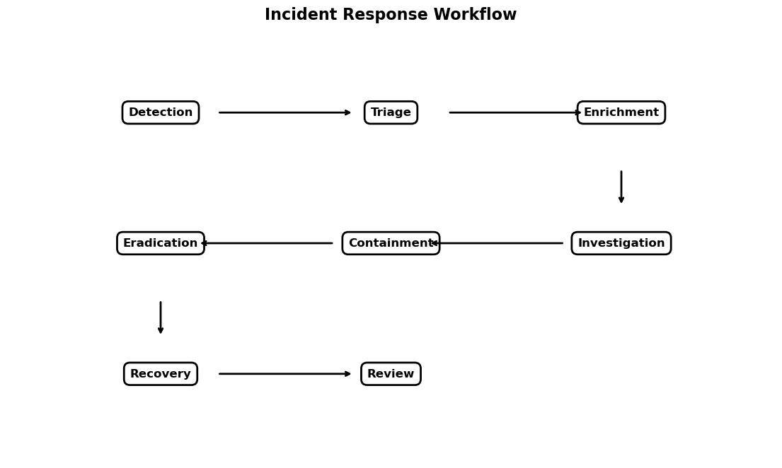
Initial Triage
- Verify alerts,
- assign severity,
- identify observables,
- create case,
- follow decision tree.

Incident Response Decision Tree

The decision tree guides analysts through key response decisions, including incident validation, investigation steps, and whether containment is required. This ensures a structured and consistent approach across all incident types.

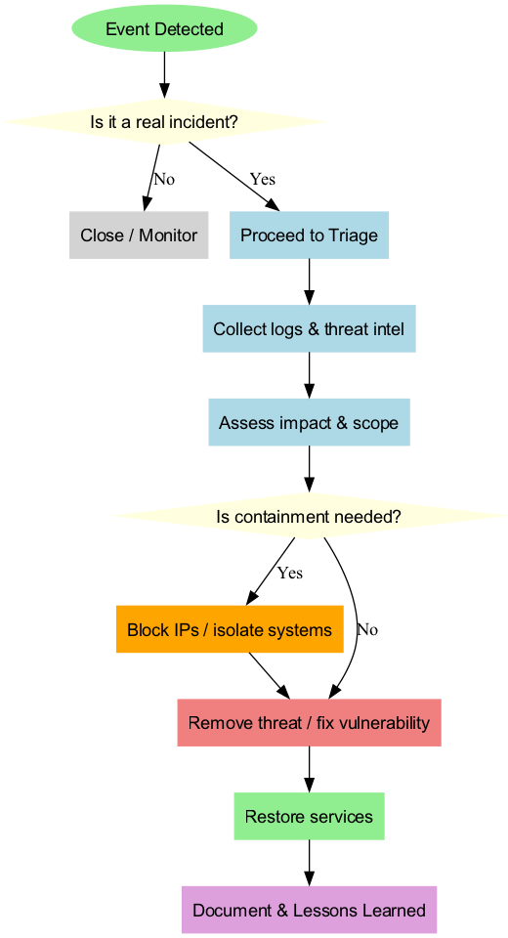

Severity Classification
- list out the levels of severity (critical, high, medium, low)
- list out what actions to take dependent on level
  - Critical: Immediate response
  - High: Rapid response
  - Medium: Monitor + investigate
  - Low: Log and monitor

Containment
- immediate actions that contain the incident and prevent escalation

Investigation
- what sort of review, investigative measures can be taken
- any specific information needed to log or identified

Eradication
- policies and actions that neutralize and prevent the incident

Recovery
- fix damage caused by incident
- any future monitoring actions
- any confirmation of following actions

Post-incident Review
- take stock on any lasting damage
- improve on any protocol

Section 2: Incident Response Playbook Report – Catnip Games SOC

Catnip Environment Overview( envirment used )
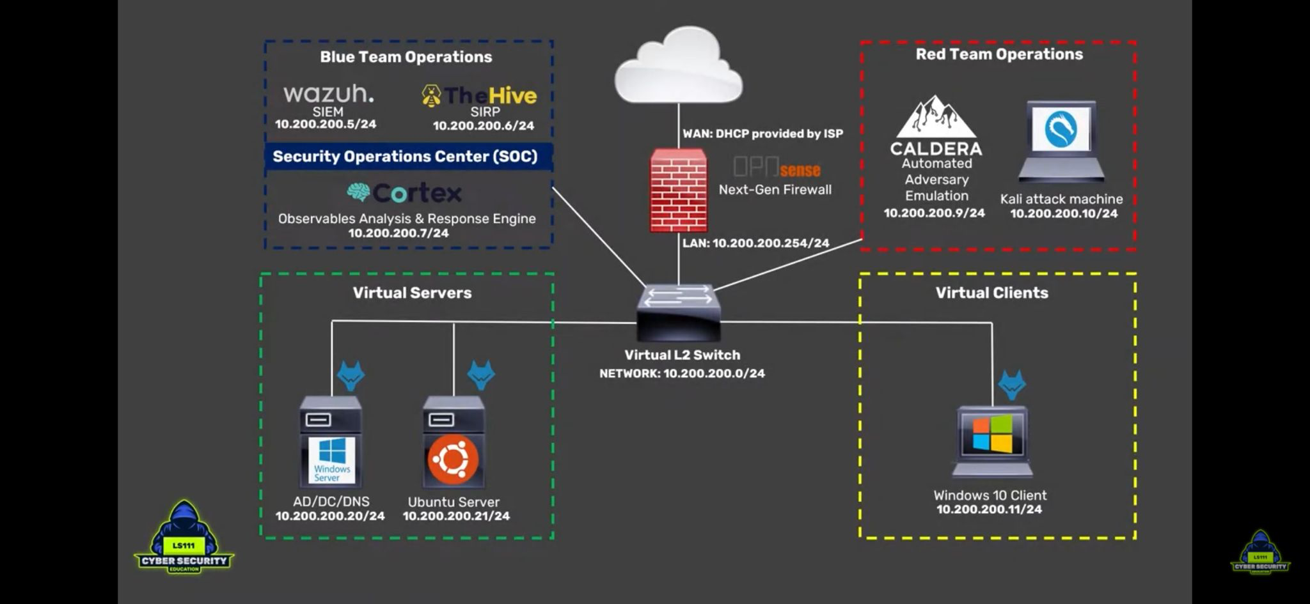

Purpose and scope: (def objectives and extent of application)

This playbook provides a standardised incident response framework for Cyber Defense Analysts within Catnip Games. It integrates TheHive, MISP, Cortex, and Elasticsearch to detect, analyse, and respond to security incidents affecting game infrastructure and player data.
Objectives:
- Outline the severity levels of various active threats (i.e. malware, botting, phishing)
- Develop standardised regulatory framework of i) documenting these threats, ii) responding and countering the damage, and iii) reviewing and improving security protocol
- Constructing communication pathways and regulation for collaboration between different teams and responsible threat management Extent:
- Reactionary to live security challenges

Tools Used
- TheHive
- MISP
- Cortex
- Elasticsearch
- Python

Roles and responsibilities: (def who is responsible for each aspect)
Security Operations Team:

SOC Manager: Oversees incidents, assigns tasks.

SOC Analysts: Perform triage, investigation, and response.

Prepartion: (readiness measures)
- Deployed MISP, Cortex, Elasticsearch
- Team training on tools and regulations

Detection & Analysis: (+ triage workflows)
- Automated logging on common MISP events
- Python scripting and Cortex dashboard for visual alert systems, to be monitored and categorised by SOT Analysts
- Critical to be handled immediately. High to be handled as soon as possible. Mediums and Lows can be triaged, but after a period of XX time, to be reassessed on severity.

Containment, eradication, recovery: (management and resoration)
- SOC Manager assigns Analysts tasks and cases via TheHive.
- Strategies to be taken specifically in response to type of attack

Post-Incident: (review, improvements)
- SOC Manager hosts a review with Analysts involved, going through incident documentation and timeline
- Improvements to process to be implemented. Patch update if needed

Communication Protocols: (internal and external communication paths, regulatory reporting requirements, escalation measures)
- Internal: Analysts standarise alert systems and incident logging. Analysts categorise threats to report to TheHive, SOC Manager monitors TheHive to assign cases. Critical and High threats are reported immediately to SOC Manager, via in-person or phone at XXXXX. SOC Manager will relay tasks.
- External: During resolution or post-incident, Analysts may confirm necessary communication to other teams or the playerbase. SOC Manager will commuicate with other team managers. SOC Manager and Analysts will report to PR Team for communication to playerbase.

Severity Levels: (+ response times)
- Critical: Must be handled immediately, else drastic data breach, game corruption, or similar consequences will occur.
- High: Must be handled as soon as possible. Defined as exploited game mechanics, bot activity, social engineering attempts
- Medium: Handled as soon as possible. Defined as general suspicious activity, or activity that has potential to escalate.
- Low: Handled whenever possible. Defined as average, mildly suspicious activity.

Section 3: Incident Response Playbook Application

This section demonstrates how the incident response playbook is applied to different cybersecurity

incidents within the Catnip Games environment.

3.1 Bot Attack

Detection: The incident was detected through __________ indicating __________.

Initial Triage: Confirmed as __________. Severity: __________. Observables: __________.

Enrichment: Indicators analysed using __________ revealing __________.

Investigation: Analysis of __________ showed __________. The attack involved __________.

Containment: Actions taken: __________.

Eradication: Root cause addressed by __________.

Recovery: Systems restored by __________.

Post-Incident Review: Improvements included __________.

3.2 Phishing

Detection: Identified through __________ indicating __________.

Initial Triage: Confirmed as __________. Severity: __________. Observables: __________.

Enrichment: Domain/URL analysed using __________ revealing __________.

Investigation: Analysis showed __________. Attack method: __________.

Containment: Actions taken: __________.

Eradication: Root cause addressed by __________.

Recovery: Accounts/systems restored by __________.

Post-Incident Review: Improvements included __________.

3.3 Malware

Detection: Detected through __________ indicating __________.

Initial Triage: Confirmed as __________. Severity: __________. Observables: __________.

Enrichment: File/hash analysed using __________ revealing __________.

Investigation: Analysis showed __________. Source: __________.

Containment: Actions taken: __________.

Eradication: Root cause addressed by __________.

Recovery: Systems restored by __________.

Post-Incident Review: Improvements included __________.

3.4 DDoS

Detection: Detected through __________ indicating __________.

Initial Triage: Confirmed as __________. Severity: __________. Observables: __________.

Enrichment: IPs analysed using __________ revealing __________.

Investigation: Analysis showed __________. Attack type: __________.

Containment: Actions taken: __________.

Eradication: Root cause addressed by __________.

Recovery: Services restored by __________.

Post-Incident Review: Improvements included __________.

